**ActiveSpaces Installation steps for *AS-D5-AgentWorks-MS* MetaSpace and *ESB_AgentWorksSpace***

1. Unzip into your C:\ Directory.
2. Go to start menu, in search type “run” without quotes, in the run window type rundll32.exe shell32.dll,Control_RunDLL sysdm.cpl,,3

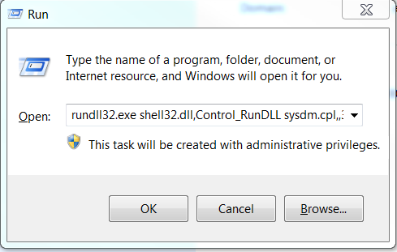

1. Click on Environment Variables:

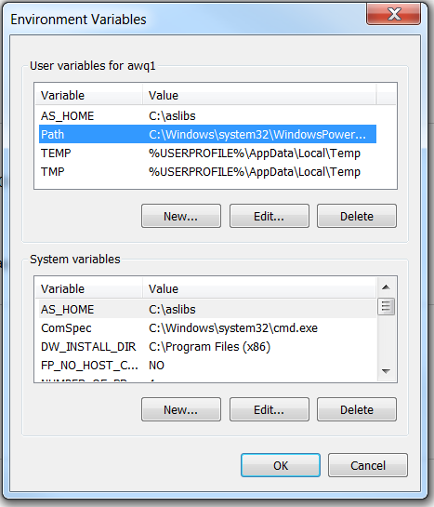

Under User variables (top section) click on path and click on edit.

At the very end add this:

C:\tibco\as\2.1\lib;C:\tibco\as\2.1\bin

Under System Variables (bottom section) click on path and click on edit.

At the very end add this:

C:\tibco\as\2.1\lib;C:\tibco\as\2.1\bin

Click ok. Then click ok again to close the Environment Variables window.

1. Open start and type command, you should see Developer Command Prompt for VS2015. Right click and open as admin.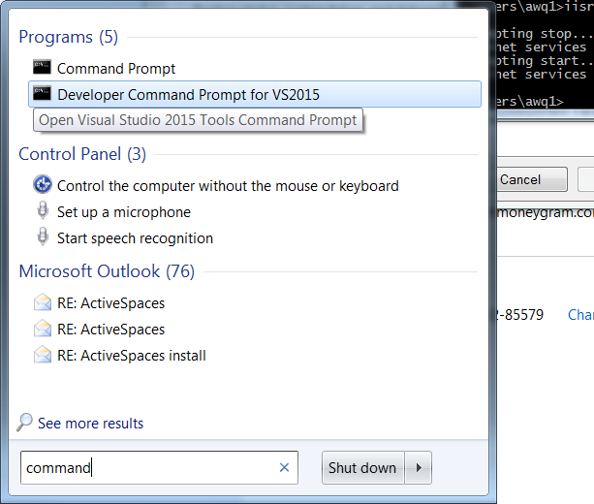

Type this: CD C:\tibco\as\2.1\lib

Then type: gacutil /if TIBCO.ActiveSpaces.Common.dll

Close out of the command prompt window.

That should be all that is required to run a deployed instance of AgentWorks API with ActiveSpaces Caching.